`DTI flow
- Profs stand behind stand
- Video plays
- Profs create hand on stand
- Profs move to sit on bench

DTI Pitch script ( mins so far)

Yapping (it's not yapping if its content) (1 min 45s)
Have you been feeling stressed?

We live in a society where it is not uncommon for us to work ourselves to the bone because we have to constantly prove our worth. Over half of workers in Singapore lack trusted relationships in the workplace, leading to feelings of isolation and loneliness. One in ten workers do not feel valued by their colleagues. [1] Workers lack a sense of self-worth and connectedness, feeling dehumanised.

Further exacerbating the lack of connectedness, there is a lack of infrastructure for play. Group play strengthens bonds through interaction and shared experiences. Families, especially the children, suffer most from the lack of play.

So, How might we reassert users' value, facilitate play and instil a sense of connectedness? Well, we can take inspiration from two sources.

Firstly, Cave paintings are one of humanity’s oldest known art forms. Our ancestors left their handprints on the cave walls as their way of communicating with their community. It was their way of saying “I exist.”

“Along the River During the Qingming Festival” is a famous Chinese painting. At a glance, the humans in the painting seem insignificant. But when we look closer, we see that each of them has a story to tell.

This brings us to our project, “We exist together!”.

VIDEO PLAYS (est 2.5 mins)
Narrator:
Has this ever happened to you?

Scene 1: Worker walking along park
“Wow my boss is chasing me for my work again, I better have a fast lunch so I can get back to work”
Worker is relaxing while walking
“At least I can enjoy the park while I’m walking through. Look at that bird.”

Worker enters underpass
Wow this place is so damp and dark. The concrete so brutalist also. How am I supposed to relax??? My immersion is broken!!!

Scene 2: A parent with child (Vania) is walking through the park
Wow this park has no activities for my child to engage in. This park is lacking in functionality to me which limits my time spent here. 1/5 stars!

Parent and child is inside underpass
“"Moooom this is so boooring"”
“Ok! Let's GTFO!”

Scene 3:
Narrator:
Picture of site map
Since families visit on weekends and workers visit on weekdays, there is currently little interaction between user groups. This trend is exacerbated by the current unpleasant state of the underpass that connects the two halves. Since entering it breaks the user's immersion of the park, users are incentivised to stay within their half of the loop.

Split screen of Worker and family pretending to interact with stand
Despite the time and space barrier, there remains value in the interaction between diverse user groups through a shared activity which allows them to share their experiences, stemming from their varying age groups and professions. This engagement taps into our rich social fabric, allowing users to form social ties that ultimately provide perspective and bridge communities. This thus enriches their lives, leading to greater satisfaction.

Scene 4: Animation of pan in from underpass
Introducing “We exist together!” a moving display. That seeks to enrich the unwinding process and maximise the use of the park as a non-commercial third space.

Scene 5: Slow pan of hands walking
In this moving display, hands are the main focus because as explained, they are an integral part of our humanity. Our group takes inspiration from the “Along the River During the Qingming Festival” painting but localizes it by presenting it in the form of a Kampung aesthetic to bring out Singaporeans' sense of community.

Watching the hands go about their day, make art and chat with one another provides the user with aesthetic pleasure and only requires the user's passive involvement. Such a climate intrigues the users allowing for soft fascination, which enables the recovery of directed attention and the window for serious reflection.

Scene 5b: zoom out to be in front of stand:
Each of the hands you see are created and customised by a user.Would you like to try?

UIUX walkthrough (3mins 15s)
Video ends at Profs pov since they are already in front of stand

New users visiting the stand may choose to visit and reference others. Thus, they click in to visit.

Guide the profs to click into Sathya’s one

Heartmode Sathya, his recording starts playing, heart starts pulsating.

Once observed, they will then go back and create their own hand. (due to time constraint only one prof will create)

Proceed, measure heart rate
Enter nickname
Customise

Heart mode recording slide 1:
Our interactions, relationships, and the bonds we form with others are essential parts of what makes us feel alive and connected to the world around us. Through our connections, we learn empathy, compassion, and understanding, which are fundamental aspects of our humanity. These connections humanise us.

Heart mode recording slide 2:
- Can you think of one person who is meaningful to you? Why are they meaningful to you?
- Is there someone who you had a positive or meaningful interaction with today? Tell us about it!
- Can you describe something or someone that you have made a significant impact on?

Heart mode recording slide 3 (finished recording):
Our lives are connected! We exist together! We hope those questions showed how we're all part of a vast web of relationships and experiences that shape who we are and how we navigate the world. Each person we encounter, each story we hear, adds another layer to the fabric of our existence. Other users will be able to hear your story, just as you will be able to hear theirs!

Hand formed

Bring them back to activity page 2 to find their hand

Show that recorded heartbeat pulsates and recorded recording plays.

Proof of concept (Joshua) (<2 min)(add content pls)

- TLDR; Explain Brief the way the electronics/ program works,
- The various modes the code goes thru for the various processes (Heart rate, heart pulse, voice record+ playback)
- Shortcomings (motor too weak to create a consistent “Pulse” of a user.)

So there are a few main components that help add a more human element into our design for people to interact even across different time periods.

The first is the heart rate sensor, it is coordinated through an arduino microcontroller with the LED strip for a more responsive user experience, and this arduino also coordinates the voice recording and story playback. The corresponding colours can be seen here.

The other component is this heartbeat-mimicking machine, which converts the rotational motion that is usually provided by a motor into a vertical motion to produce the sensation of a heart “beat”. We are currently using a hand-crank because the motor we have bought is too weak, as you can see; we could try supplying it with up to 12V, but doing so would risk frying Arduino. But we still keep this concept because it lets us produce a very consistent thumping motion. ( takes out the crank) Instead of using many complicated gears and pivots that take up a lot of space, we thought of a method that uses a hexagonal axle and an oval-shaped gear to apply a force on the stick, which is held in place with a holster that produces normal forces to cancel out the horizontal torque.

But this is only for this part of our project; I’ll be handing it off to Vania to explain to you how our project leverages the interactions between the projection and the site itself to bring people together, so please, feel free to take a seat.

Explanation of scale model (Vania) (1 min)(add content pls)
Invite profs to sit
Explaining aesthetic
Watching the hands go about their day, make art and chat with one another provides the user with aesthetic pleasure and only requires the user's passive involvement. Such a climate intrigues the users allowing for soft fascination, which enables the recovery of directed attention and the window for serious reflection.

in addition to soft fascination:

(Show pics of cafes, library and cinema) What do these three things have in common? They are third spaces, or places distinct from one's home or workplace, where people can gather to exchange ideas, build relationships and have a good time. These ‘third places’ enrich social interaction, a sense of community, and belonging outside of the home and workplace by providing an outlet for built-up stress and a persistent space to meet new faces and interact with others. By integrating resting spots into our site, we hope to achieve this.

Script for scale model
This thing here is our display board which consists of 4 boards and our prototype here is 1 part of it. You are currently sitting over here. The reason why we added a bench is so that the users can experience soft fascination. We also provide the bench so it can be their 3rd space where they can just sit down to relax and interact with other people. Another reason we added the bench is because of the low height limit of the underpass. So for the user to avoid blocking the projector they need to sit down. They can also reach out their hand to play with the shadow, especially the people who don't really understand the concept of our project. We are also adding a mural that has the same theme to the aqueduct wall to replace the brutalist aesthetic of the current underpass.

Conclusion:(30s)
In conclusion, in tackling our problem statement:
How might we alleviate the underpass's lack of draws in a way that engages both business and leisure user groups in a shared activity that provides perspective and helps reassert their humanity, enriching the unwinding process and maximising the use of the park as a non-commercial third space?

Our group transforms the underpass into a third space with a shared activity that provides for play and soft fascination. This enriches the unwinding process by reminding the user of their connectedness and of their significance.

Sampled texts

Over half of workers in Singapore (55 per cent) lack trusted relationships in the workplace, leading to feelings of isolation and loneliness

One in ten workers do not feel valued and respected by their colleagues
https://sg.news.yahoo.com/more-than-half-workers-singapore-do-not-have-trusted-workplace-relationships-one-in-ten-dont-feel-respected-valued-by-colleagues-report-031557672.html?guccounter=1&guce_referrer=aHR0cHM6Ly93d3cuZ29vZ2xlLmNvbS8&guce_referrer_sig=AQAAAKEQYXD1QvCP6ScBB26Hfuw74ZSMAy4a6dQcyl2rZwb-P7QsxdyQYgJsxodUAYhqulSZKg7CICFs9f7jUqmuPiBS6LJKIRPDVs3RFKZF-xJkkwqgE1oUvtSlYk11pq8nCCAQdDijr6njC59v7TQzYjCC4tnRaJF9XYKvVQXJzunD

The principal horror of any system which defines the
good in terms of profit rather than in terms of human
need, or which defines human need to the exclusion of
the psychic and emotional components of that need - the
principal horror of such a system is that it robs our work
of its erotic value, its erotic power and life appeal and
fulfillment. Such a system reduces work to a travesty of
necessities, a duty by which we earn bread or oblivion
for ourselves and those we love.

the three C’s underlying strong psychological contracts — a career that offers personal growth and upward mobility, a community that fosters social connections and belongingness, and a cause that infuses one’s work with meaning and purpose

Many drivers in the on-demand economy, I found, struggled to answer this question. One driver I interviewed explained, “I try to bring my personality, but the app itself doesn’t really offer that…the app sets the precedent to dehumanize…if you don’t try to inject your personality, it just washes it out…I feel like a robot by the end of the day.” A different driver put it more bluntly: “The driver is invisible [to customers]…the driver doesn’t exist…it’s like you’re not really there.”
https://hbr.org/2022/06/dehumanization-is-a-feature-of-gig-work-not-a-bug

Problem | Parks use as a place to destress is not maximised  How might we engage users in a shared activity and maximise the parks use as a non-commercial third space to provide levity and perspective into their lives, thus enriching the unwinding process
Site and Users | Site: underpass connecting the 2 halves of CBPP  This area is ideal as it connects the two halves. It will act as a common point for the 2 user groups and encourage the users to venture further into the park.  Users: business workers, families with children, joggers
Design Process | Ideation  We wanted to create a product that could unite users regardless of space and time boundaries. Our main theme was community.  Our initial idea was inspired by cave painting and “qing ming he shang tu”  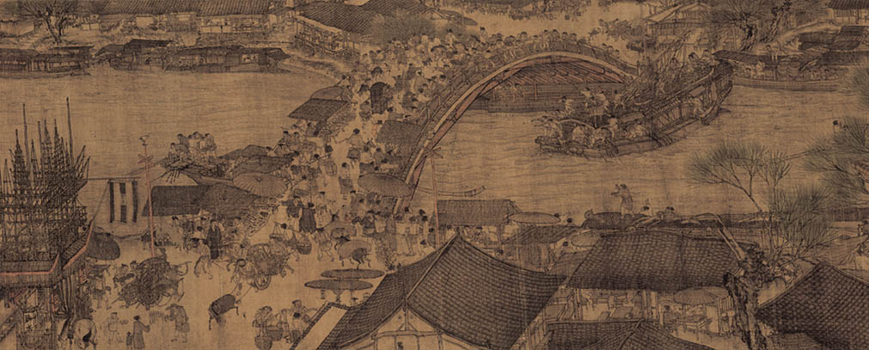  Cave paintings are one of the earliest forms of art, so it brings us back to our roots. The typical handprints on the wall help mark the presence of the artist
Validation
Next Steps

